SE Lab, 18 March 2019.
Unique Cloud setup and execution tools– cloud based software and tools Report

Team:
18MCMB13, A Jagadeesh (M.Tech. I.T)
18MCMB08 , Prathamesh Sanga (M.Tech. I.T)
18MCMB11 , Pranshu Mishra (M.Tech. I.T)
18MCMB15 , G Hareesh (M.Tech. I.T)

Deploying a “Hello world ” code on AWS EC2 instance

Step:1 Create an AWS account.

Signup using the below link..
https://signin.aws.amazon.com/signin?redirect_uri=https%3A%2F%2Fconsole.aws.amazon.com%2Fconsole%2Fhome%3Fstate%3DhashArgs%2523%26isauthcode%3Dtrue&client_id=arn%3Aaws%3Aiam%3A%3A015428540659%3Auser%2Fhomepage&forceMobileApp=0

Step 2:Login into AWS account

AWS management console looks something like this:
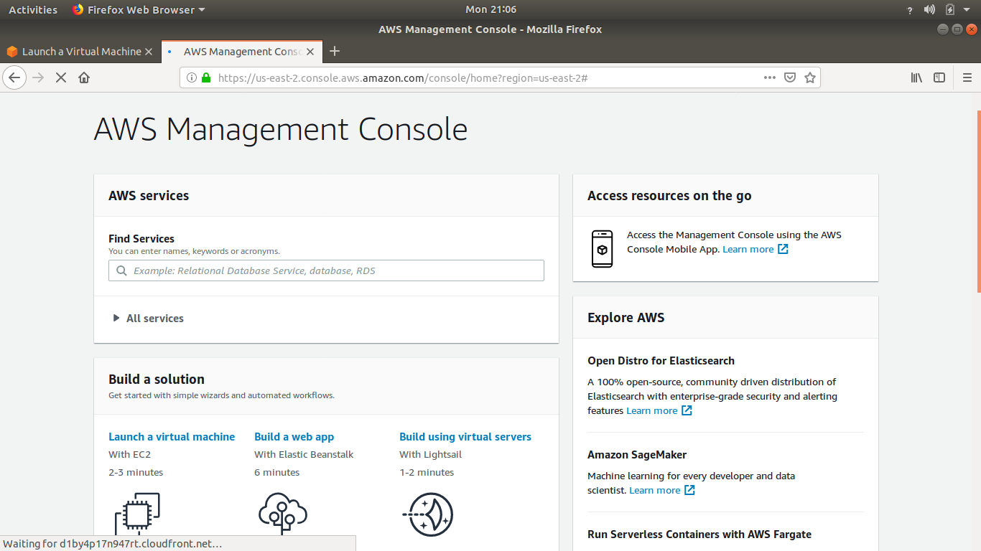

Step 3. Launch an Amazon EC2 Instance
a)Type EC2 in the search bar and select Amazon EC2 to open the service console.
b) Select Launch Instance to create and configure your virtual machine.
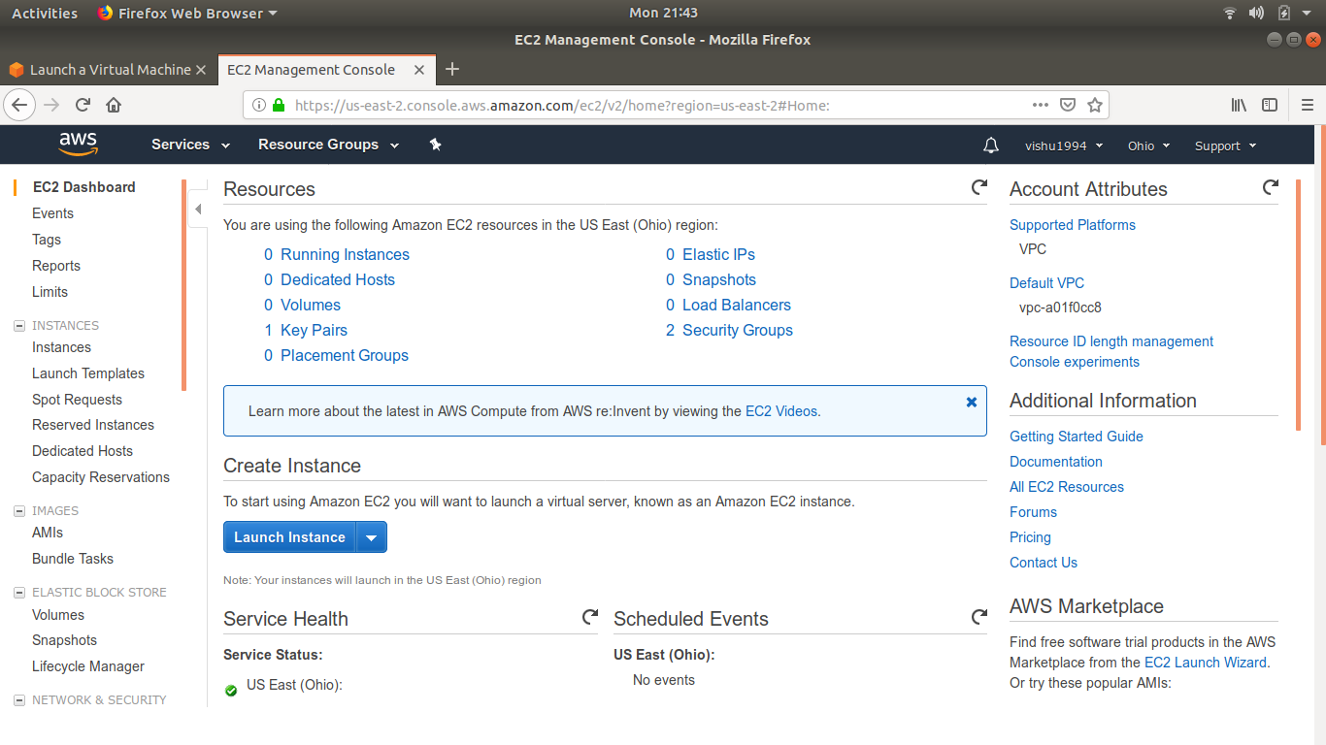

Step 4. Configure your Instance
a)In this screen, you are shown options to choose an Amazon Machine Image (AMI). AMIs are preconfigured server templates you can use to launch an instance. Each AMI includes an operating system, and can also include applications and application servers.

We’ll choose “Ubuntu Server 18.04 LTS (HVM)”
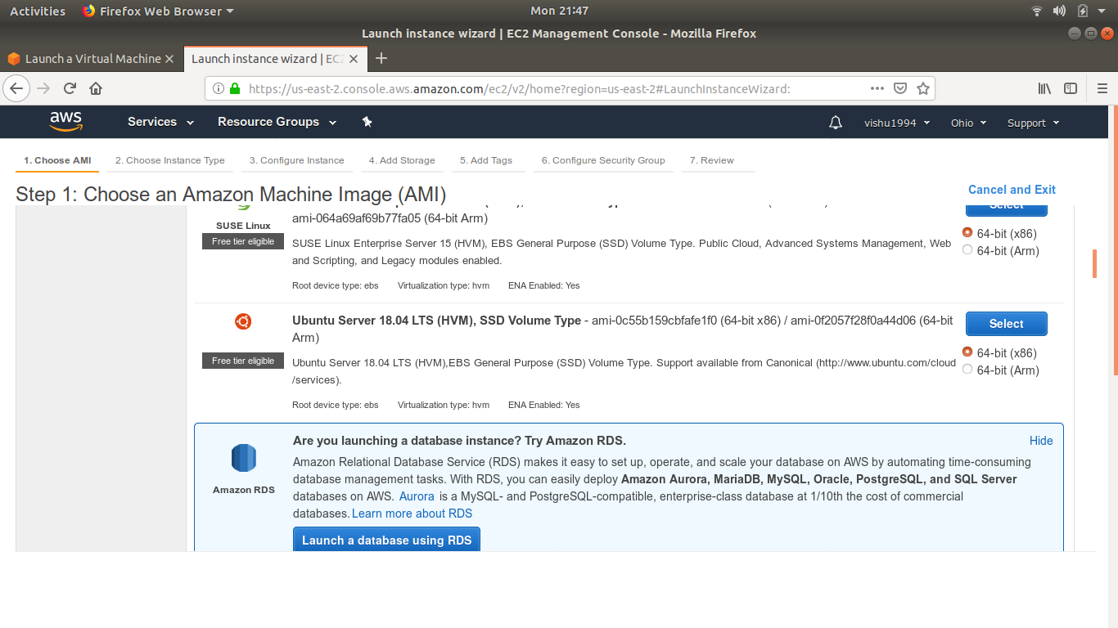
b)We will now choose an instance type. Instance types comprise of varying combinations of CPU, memory, storage, and networking capacity so we can choose the appropriate mix for your applications. For more information, see Amazon EC2 Instance Types.

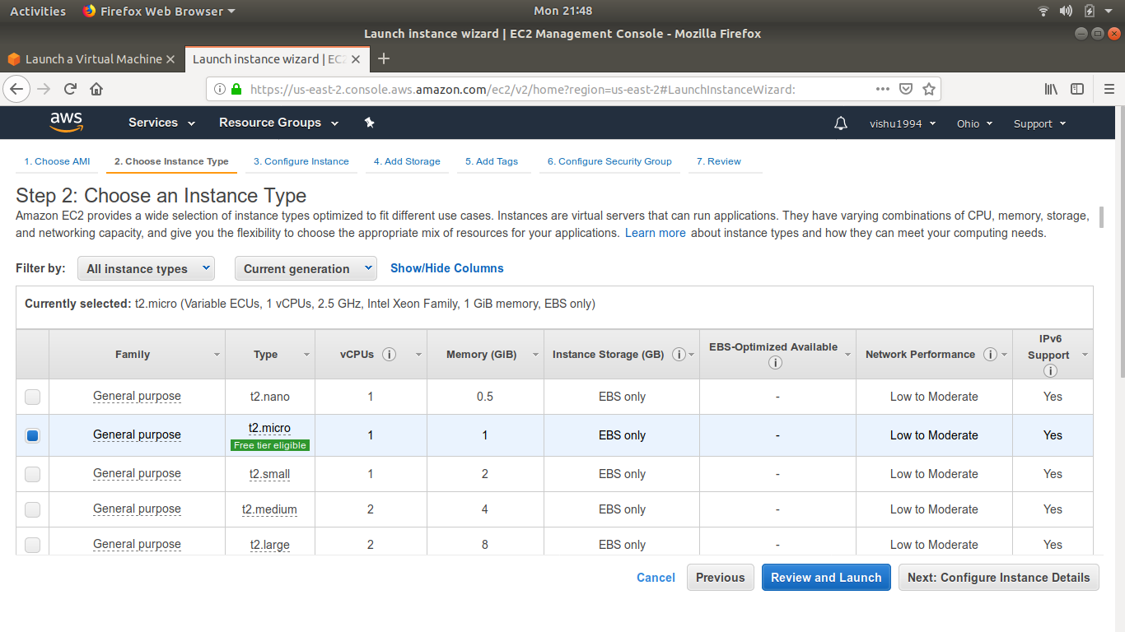

Click Review and Launch at the bottom of the page.

c) We can review the configuration, storage, tagging, and security settings that have been selected for your instance. While you have the option to customize these settings, we recommend accepting the default values for this tutorial.
Click Launch at the bottom of the page.
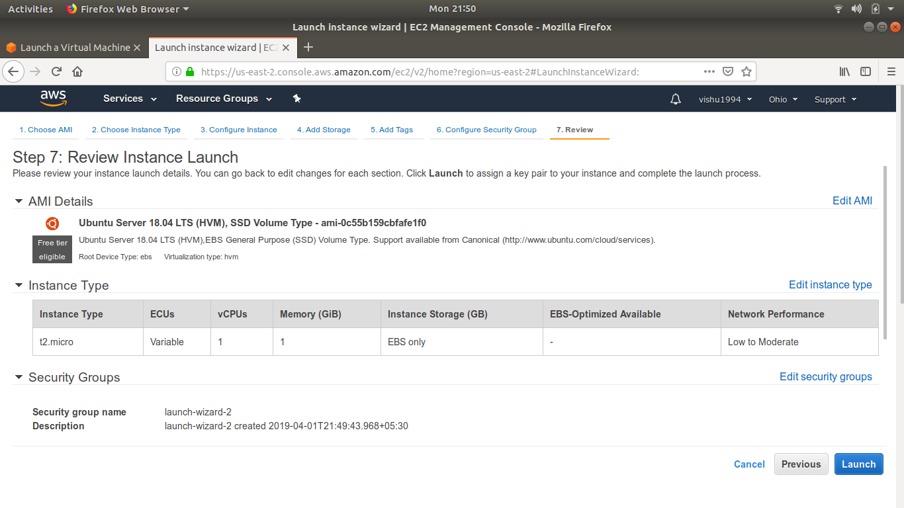

d) On the next screen we will be asked to choose an existing key pair or create a new key pair. A key pair is used to securely access our Linux instance using SSH. AWS stores the public part of the key pair which is just like a house lock. We can download and use the private part of the key pair which is just like a house key.
Select Create a new key pair and give it the name ubuntu. Next click the Download Key Pair button.
After you download the MyKeyPair key, you will want to store your key in a secure location. If you lose your key, you won't be able to access your instance. If someone else gets access to your key, they will be able to access your instance.

After you have stored your key pair, click Launch Instance to start your Linux instance.

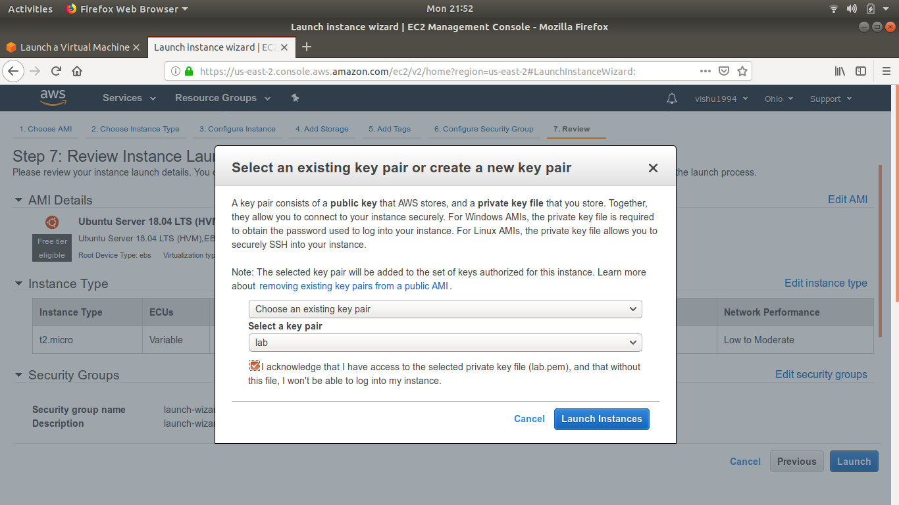
e) Click View Instances on the next screen to view your instances and see the status of the instance you have just started.

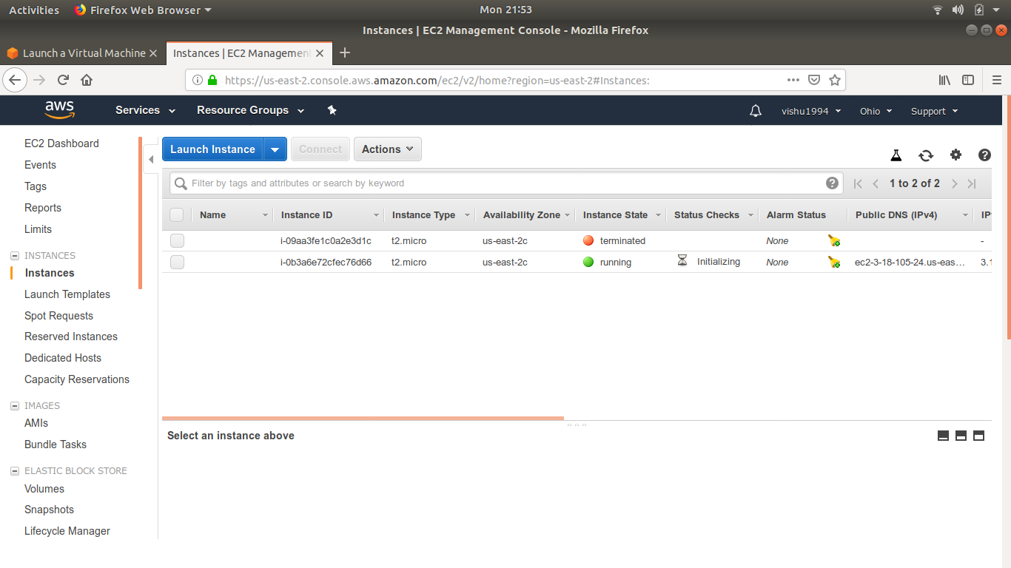

f)In a few minutes, the Instance State column on your instance will change to "running" and a Public IP address will be shown. You can refresh these Instance State columns by pressing the refresh button on the right just above the table. Copy the Public IP address of your AWS instance, so you can use it when we connect to the instance using SSH in Step 4.

Step 5. Connect to your Instance
After launching your instance, it's time to connect to it using SSH.

a. Your Mac or Linux computer most likely includes an SSH client by default. You can check for an SSH client by typing ssh at the command line. If your computer doesn't recognize the command, the OpenSSH project provides a free implementation of the full suite of SSH tools that you can download.
Mac users: Open a terminal window by pressing Command + Space and typing terminal in the search window. Then press enter to open the terminal window.
Linux users: Open a terminal window.

b.Use the chmod command to make sure your private key file is not publicly viewable by entering the following command to restrict permissions to your private SSH key:

chmod 400 mykeypair.pem
You do not need to do this every time you connect to you instance, you only need to set this once per SSH key that you have.

c. Use SSH to connect to your instance. In this case the user name is ec2-user, the SSH key is stored in the directory we saved it to in step 3 part d, and the IP address is from step 3 part f. The format is:
ssh -i {full path of your .pem file} ec2-user@{instance IP address}
Enter the following:
ssh -i ~/.ssh/MyKeyPair.pem ec2-user@{IP_Address}

You'll see a response similar to the following:
The authenticity of host 'ec2-198-51-100-1.compute-1.amazonaws.com (10.254.142.33)' can't be established. RSA key fingerprint is 1f:51:ae:28:df:63:e9:d8:cf:38:5d:87:2d:7b:b8:ca:9f:f5:b1:6f. Are you sure you want to continue connecting (yes/no)?

Type yes and press enter.

STEP 6: Open NANO editor and write the “C” code for hello world and save it.

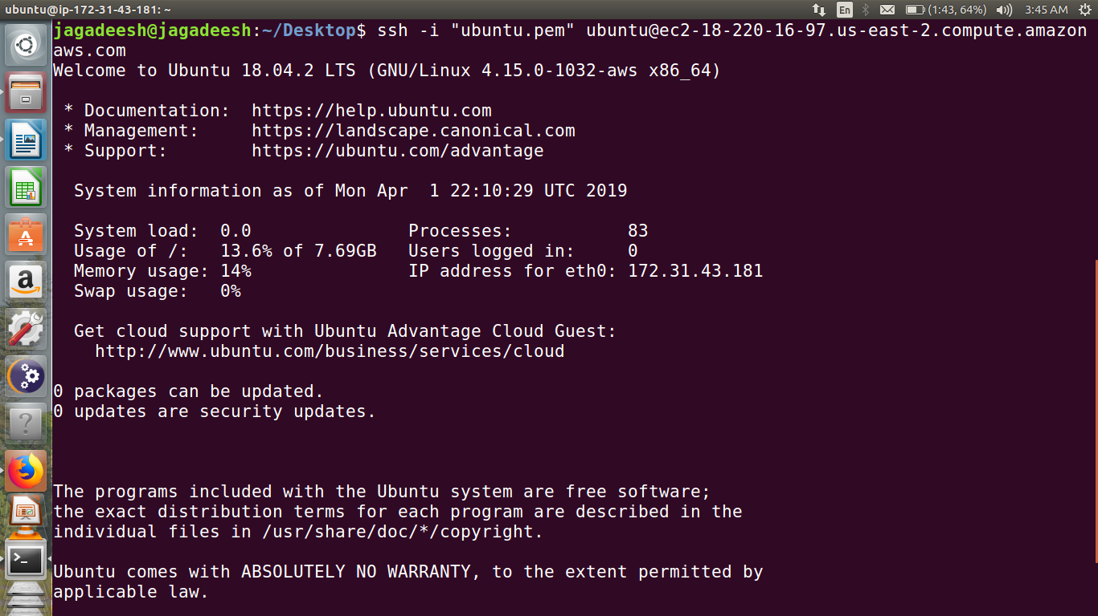
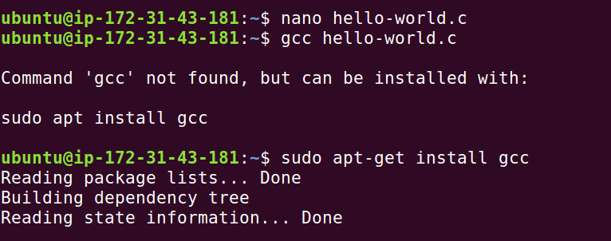

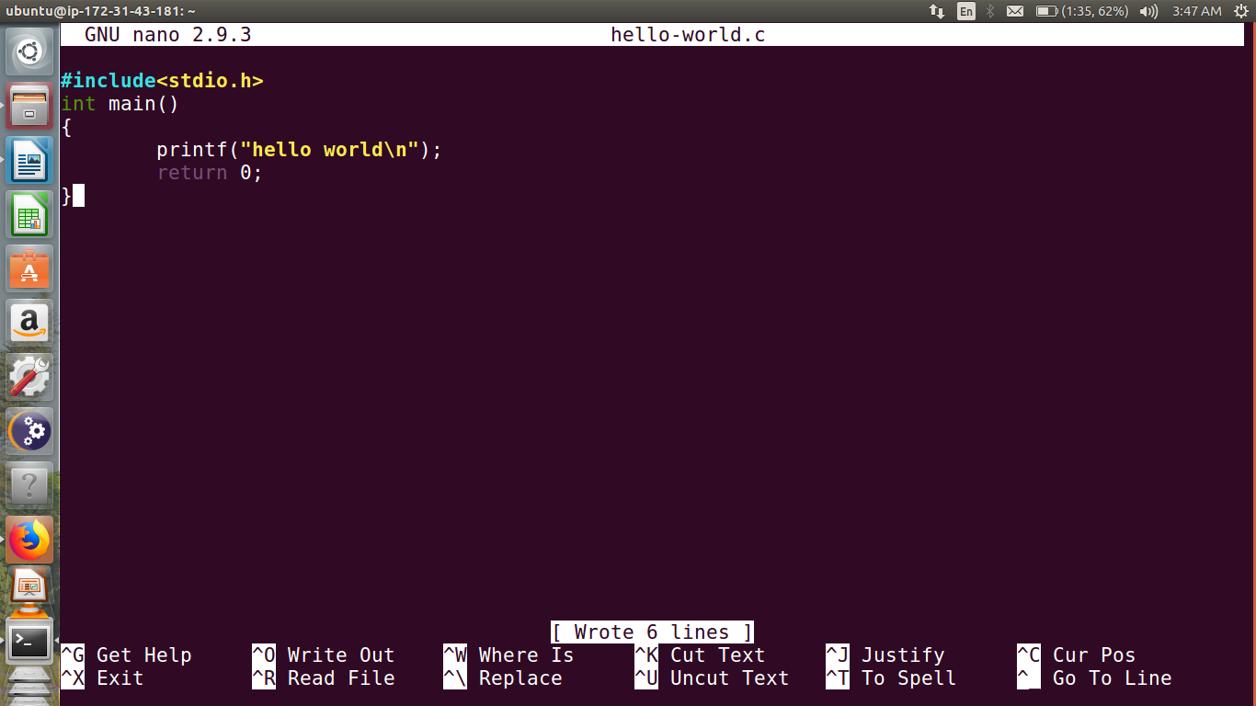
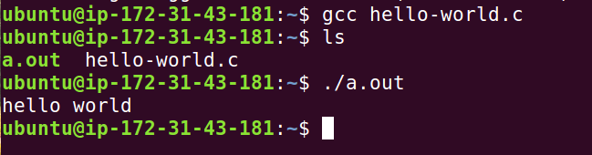
STEP 7: Run the python program from terminal.

